CC MOD 2

**Evolution of Cloud Computing**

Cloud computing is all about renting computing services.  In making cloud computing what it is today, five technologies played a vital role. These are distributed systems and its peripherals, virtualization, web 2.0, service orientation, and utility computing.

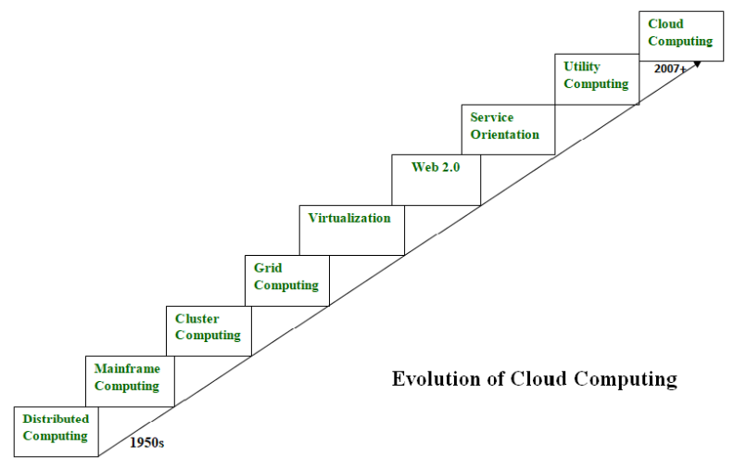

**Distributed Systems:**   
It is a composition of multiple independent systems but all of them are depicted as a single entity to the users. The purpose of distributed systems is to share resources and also use them effectively and efficiently. Distributed systems possess characteristics such as scalability, concurrency, continuous availability, heterogeneity, and independence in failures. But the main problem with this system was that all the systems were required to be present at the same geographical location. Thus to solve this problem, distributed computing led to three more types of computing and they were-Mainframe computing, cluster computing, and grid computing.

**Mainframe computing:**   
These are responsible for handling large data such as massive input-output operations. Even today these are used for bulk processing tasks such as online transactions etc. These systems have almost no downtime with high fault tolerance. After distributed computing, these increased the processing capabilities of the system. But these were very expensive. To reduce this cost, cluster computing came as an alternative to mainframe technology.

**Cluster computing:**   
Each machine in the cluster was connected to each other by a network with high bandwidth. These were way cheaper than those mainframe systems. These were equally capable of high computations. Also, new nodes could easily be added to the cluster if it was required. Thus, the problem of the cost was solved to some extent but the problem related to geographical restrictions still pertained. To solve this, the concept of grid computing was introduced.

**Grid computing:**

It means that different systems were placed at entirely different geographical locations and these all were connected via the internet. These systems belonged to different organizations and thus the grid consisted of heterogeneous nodes. The main problem which was encountered was the low availability of high bandwidth connectivity and with it other network associated issues. Thus. cloud computing is often referred to as “Successor of grid computing”.

**Virtualization:**  
It refers to the process of creating a virtual layer over the hardware which allows the user to run multiple instances simultaneously on the hardware. It is a key technology used in cloud computing. It is the base on which major cloud computing services such as Amazon EC2, VMware vCloud, etc work on. Hardware virtualization is still one of the most common types of virtualization.

**Web 2.0:**   
It is the interface through which the cloud computing services interact with the clients. It is because of Web 2.0 that we have interactive and dynamic web pages. It also increases flexibility among web pages. Popular examples of web 2.0 include Google Maps, Facebook, Twitter, etc.

**Service orientation:**   
It acts as a reference model for cloud computing. It supports low-cost, flexible, and evolvable applications. Two important concepts were introduced in this computing model. These were Quality of Service (QoS) which also includes the SLA (Service Level Agreement) and Software as a Service (SaaS).

**Utility computing:**   
It is a computing model that defines service provisioning techniques for services such as compute services along with other major services such as storage, infrastructure, etc which are provisioned on a pay-per-use basis.

Comparison between Cluster, Grid and Cloud Computing:

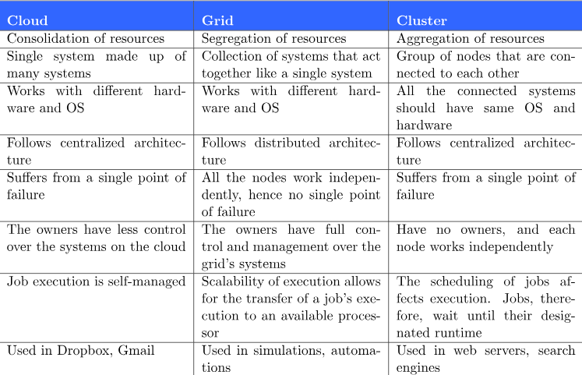

### Benefits of Cloud Computing:

1. **Cost Efficiency**:
   * **Benefit**: Cloud computing allows organizations to reduce capital expenses by eliminating the need for upfront hardware and infrastructure investments. They can instead opt for a pay-as-you-go model, where they only pay for the resources they use.
   * **Example**: Companies can scale their computing resources up or down based on demand, avoiding over-provisioning and reducing overall IT costs.
2. **Scalability and Flexibility**:
   * **Benefit**: Cloud services offer scalability, allowing businesses to easily scale their resources up or down based on demand. This flexibility enables rapid deployment of applications and services.
   * **Example**: During peak periods, such as holiday shopping seasons, companies can quickly scale up their computing resources to handle increased traffic and then scale them down during quieter periods.
3. **Accessibility and Remote Collaboration**:
   * **Benefit**: Cloud computing provides ubiquitous access to applications and data from anywhere with an internet connection. This enables remote work, collaboration among distributed teams, and access to resources on various devices.
   * **Example**: Employees can access work-related documents, applications, and tools from home, while traveling, or from remote locations, enhancing productivity and collaboration.
4. **Reliability and High Availability**:
   * **Benefit**: Cloud providers offer robust infrastructure with redundant systems and data backups, ensuring high availability and reliability of services.
   * **Example**: Cloud platforms distribute data across multiple data centers, minimizing the risk of data loss due to hardware failures or disasters. They also provide automatic failover mechanisms to maintain service continuity.
5. **Elasticity**:
   * **Benefit**: Cloud computing allows for elasticity, enabling resources to be provisioned and de-provisioned dynamically in response to changing workload demands.
   * **Example**: Organizations can automatically scale resources based on traffic patterns or performance metrics, ensuring optimal performance and cost-efficiency.

### Challenges of Cloud Computing:

1. **Security and Privacy Concerns**:
   * **Challenge**: Cloud computing raises concerns about the security and privacy of data stored in the cloud. Organizations may worry about data breaches, unauthorized access, or compliance with regulations.
   * **Example**: Storing sensitive information, such as personal or financial data, in the cloud requires robust security measures, including encryption, access controls, and regular security audits.
2. **Dependency on Internet Connectivity**:
   * **Challenge**: Cloud computing relies heavily on internet connectivity. Any disruptions in connectivity can lead to service outages, data access issues, or interruptions in business operations.
   * **Example**: Organizations in remote areas or with unreliable internet connections may face challenges in accessing cloud services consistently, impacting productivity and performance.
3. **Vendor Lock-In**:
   * **Challenge**: Adopting cloud services from a specific provider may lead to vendor lock-in, making it difficult to migrate data and applications to another provider or on-premises environment.
   * **Example**: As organizations invest more resources into a particular cloud platform, they may encounter difficulties in switching providers due to compatibility issues, proprietary technologies, or contractual constraints.
4. **Performance and Latency**:
   * **Challenge**: Cloud computing performance may be impacted by network latency, especially for applications requiring low latency or high throughput.
   * **Example**: Real-time applications, gaming, or high-frequency trading systems may experience performance degradation when running in the cloud due to network latency between client devices and cloud servers.
5. **Data Transfer Costs**:
   * **Challenge**: Transferring large volumes of data to and from the cloud can incur significant data transfer costs, especially if data needs to be moved frequently between on-premises and cloud environments.
   * **Example**: Organizations may encounter unexpected expenses when migrating data to the cloud or when transferring data between different cloud regions or providers, impacting overall cost-effectiveness.

Cloud Deployment Model: https://www.guru99.com/cloud-deployment-models.html

The cloud deployment model identifies the specific type of cloud environment based on ownership, scale, access, and the cloud’s nature and purpose. There are various deployment models are based on the location and who manages the infrastructure.

Public Cloud:

* The Public Cloud allows systems and services to be easily accessible to the general public.
* Public cloud may be less secure because of its openness, e.g., e-mail.
* Public clouds are owned and operated by third parties.
* Deliver superior economies of scale to customers
* Pay-as-you-go
* Public cloud may be larger than an enterprises cloud, thus providing the ability to scale seamlessly, on demand.
* It is a multitenancy architecture, so data is highly likely to be leaked
* Examples of Public Cloud:
  1. Google App Engine
  2. IBM Smart Cloud
  3. Amazon
  4. Azure

### Advantages of Public Cloud Deployments

* Highly available anytime and anywhere, with robust permission and authentication mechanism.
* There is no need to maintain the cloud.
* Does not have any limit on the number of users.
* The cloud service providers fully subsidize the entire Infrastructure. Therefore, you don’t need to set up any hardware.
* Does not cost you any maintenance charges as the service provider does it.

### Disadvantages of Public Cloud Deployments

* It has lots of issues related to security.
* Privacy and organizational autonomy are not possible.
* You don’t control the systems hosting your business applications.

Private Cloud:

* Accessible within an organization. It offers increased security because of its private nature.
* Private clouds are built exclusively for a single enterprise.
* They aim to address concerns on data security and offer greater control, which is typically lacking in a public cloud.
* There are two variations to a private cloud:

1. On-premise Private Cloud
2. Externally hosted Private Cloud
3. On-premise Private Cloud:

On-premise private clouds, also known as internal clouds are hosted within one’s own data center. This model provides a more standardized process and protection, but is limited in aspects of size and scalability. IT departments would also need to incur the capital and operational costs for the physical resources. This is best suited for applications which require complete control and configurability of the infrastructure and security.

1. Externally hosted Private Cloud:

This type of private cloud is hosted externally with a cloud provider, where the provider facilitates an exclusive cloud environment with full guarantee of privacy. This is best suited for enterprises that don’t prefer a public cloud due to sharing of physical resources.

Examples of Private Cloud:

○ Eucalyptus

○ Ubuntu Enterprise Cloud - UEC (powered by Eucalyptus)

○ Amazon VPC (Virtual Private Cloud)

○ VMware Cloud Infrastructure Suite

## Hybrid Cloud Model

* A hybrid cloud deployment model combines public and private clouds. Creating a hybrid cloud computing model means that a company uses the public cloud but owns on-premises systems and provides a connection between the two.
* They work as one system, which is a beneficial model for a smooth transition into the public cloud over an extended period.
* The Hybrid cloud environment is capable of providing on-demand, externally provisioned scale.
* The ability to augment a private cloud with the resources of a public cloud can be used to manage any unexpected flows in workload.
* Example of Hybrid Cloud: VMware vCloud (Hybrid Cloud Services)

## Community Cloud Model

* Community clouds are cloud-based infrastructure models that enable multiple organizations to share resources and services based on standard regulatory requirements.
* It provides a shared platform and resources for organizations to work on their business requirements.
* This Cloud Computing model is operated and managed by community members, third-party vendors, or both. The organizations that share standard business requirements make up the members of the community cloud.
* You can establish a low-cost private cloud.
* It helps you to do collaborative work on the cloud.
* It is cost-effective, as multiple organizations or communities share the cloud.
* Examples of Community Cloud:
  1. Google Apps for Government
  2. Microsoft Government Community Cloud

## How to select the suitable Cloud Deployment Models

Companies are extensively using these [cloud computing models](https://www.guru99.com/types-of-cloud-computing.html) all around the world. Each of them solves a specific set of problems. So, finding the right Cloud Deployment Model for you or your company is important.

Here are points you should remember for selecting the right Cloud Deployment Model:

* **Scalability:** You need to check if your user activity is growing quickly or unpredictably with spikes in demand.
* **Privacy and security:**Select a service provider that protects your privacy and the security of your sensitive data.
* **Cost**: You must decide how many resources you need for your cloud solution. Then calculate the approximate monthly cost for those resources with different cloud providers.
* **Ease of use:**You must select a model with no steep learning curve.
* **Legal Compliance:**You need to check whether any relevant low stop you from selecting any specific cloud deployment model.

Cloud Computing Service Delivery Models:

Service Models are the reference models on which the Cloud Computing is based. These can be categorized into three basic service models as listed below:

Software as a Service (SaaS):

* In this model, a complete application is offered to the customer, as a service on demand.
* A single instance of the service runs on the cloud & multiple end users are serviced.
* On the customer’s side, there is no need for upfront investment in servers or software licenses, while for the provider, the costs are lowered, since only a single application needs to be hosted & maintained.
* Today SaaS is offered by companies such as Google, Salesforce, Zoho, etc.

Platform as a Service (PaaS):

* A layer of software, or development environment is encapsulated & offered as a service, upon which other higher levels of service can be built.
* The customer has the freedom to build his own applications, which run on the provider’s infrastructure.
* To meet manageability and scalability requirements of the applications, PaaS providers offer a predefined combination of OS and application servers, such as LAMP platform (Linux, Apache, MySql and PHP), restricted J2EE,Ruby etc.
* Google’s App Engine, Force.com, etc. are some of the popular PaaS examples.

Infrastructure as a Service (IaaS):

* Physically, the pool of hardware resource is pulled from a multitude of servers and networks usually distributed across numerous data centers, all of which the cloud provider is responsible for maintaining.
* IaaS provides a layer of virtualized hardware that delivers the computing power and data centers required for applications to run.
* Amazon Elastic Cloud Compute (Amazon EC2), Rackspace Cloud Servers, GoGrid, Joyent, and AppNexus

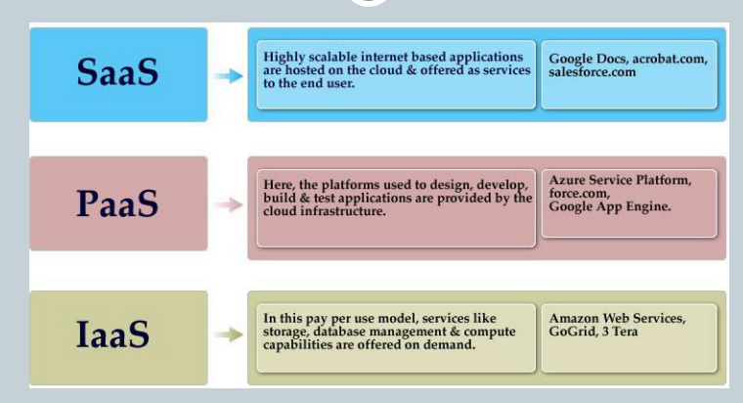

Service abstraction:

Service abstraction in cloud computing refers to the process of hiding complex underlying infrastructure details and providing users with simplified, high-level interfaces to access and utilize cloud services. It allows users to interact with cloud resources without needing to understand the intricacies of the underlying hardware or software systems. Service abstraction enables greater flexibility, scalability, and ease of use in cloud computing environments.

Service abstraction in cloud computing offers several benefits:

* **Simplified Management:** By abstracting away the underlying complexity of infrastructure and services, users can focus on their core tasks without getting bogged down by infrastructure management tasks.
* **Increased Flexibility:** Users can easily scale resources up or down based on their changing needs, without needing to make changes to underlying infrastructure configurations.
* **Improved Efficiency:** Service abstraction allows for more efficient resource utilization and automation of tasks, leading to cost savings and improved productivity.
* **Faster Time-to-Market:** With pre-configured environments and ready-to-use services, developers can quickly deploy applications and services, reducing time-to-market and accelerating innovation.

SPI MODEL:

The SPI model in cloud computing stands for Software, Platform, and Infrastructure, representing the three primary service models or layers offered by cloud service providers. These models provide different levels of abstraction and functionality, catering to varying user requirements and use cases.

**Difference between Cloud Computing and Traditional Computing :**

| **Cloud Computing** | **Traditional Computing** |
| --- | --- |
| It refers to delivery of different services such as data and programs through internet on different servers. | It refers to delivery of different services on local server. |
| It takes place on third-party servers that is hosted by third-party hosting companies. | It takes place on physical hard drives and website servers. |
| It is ability to access data anywhere at any time by user. | User can access data only on system in which data is stored. |
| It is more cost effective as compared to tradition computing as operation and maintenance of server is shared among several parties that in turn reduce cost of public services. | It is less cost effective as compared to cloud computing because one has to buy expensive equipment’s to operate and maintain server. |
| It is more user-friendly as compared to traditional computing because user can have access to data anytime anywhere using internet. | It is less user-friendly as compared to cloud computing because data cannot be accessed anywhere and if user has to access data in another system, then he need to save it in external storage medium. |
| It requires fast, reliable and stable internet connection to access information anywhere at any time. | It does not require any internet connection to access data or information. |
| It provides more storage space and servers as well as more computing power so that applications and software run must faster and effectively. | It provides less storage as compared to cloud computing. |
| It also provides scalability and elasticity i.e., one can increase or decrease storage capacity, server resources, etc., according to business needs. | It does not provide any scalability and elasticity. |
| Cloud service is served by provider’s support team. | It requires own team to maintain and monitor system that will need a lot of time and efforts. |
| Software is offered as an on-demand service (SaaS) that can be accessed through subscription service. | Software in purchased individually for every user and requires to be updated periodically |

XASS:

XaaS stands for "Anything as a Service" or "Everything as a Service." It is a broad term that encompasses the delivery of various services over the internet or a network, following the principles of cloud computing. XaaS extends the traditional Software as a Service (SaaS), Platform as a Service (PaaS), and Infrastructure as a Service (IaaS) models to cover a wide range of services and resources that can be provided remotely, on-demand, and typically on a subscription basis.

The concept of XaaS highlights the idea that virtually any resource, application, or functionality can be delivered and consumed as a service, leveraging cloud-based infrastructure and delivery mechanisms. Some examples of XaaS include:

1. **Storage as a Service (STaaS):** Provides scalable storage solutions over the internet, allowing users to store and access their data remotely without managing physical storage infrastructure.
2. **Database as a Service (DBaaS):** Offers database management and hosting services, allowing users to deploy, manage, and scale databases without dealing with underlying infrastructure.
3. **Security as a Service (SECaaS):** Delivers security solutions such as firewalls, intrusion detection/prevention systems, and antivirus software as cloud-based services, helping organizations protect their data and systems.

These are just a few examples, and the concept of XaaS continues to evolve as new technologies and service offerings emerge. XaaS enables organizations to access a wide range of resources and capabilities without the need for extensive upfront investments in hardware, software, and infrastructure, promoting agility, scalability, and cost-effectiveness.

1. Top of Form

Vertical and Horizontal scaling in cloud

In cloud computing, vertical and horizontal scaling are two approaches used to handle increases in workload or demand on applications and services. These scaling techniques help ensure that systems remain responsive, available, and performant under varying levels of usage. Here's an explanation of each:

### Vertical Scaling:

Vertical scaling, also known as scaling up or scaling vertically, involves increasing the capacity of a single server or resource. This typically means adding more CPU, memory, storage, or other resources to the existing server or upgrading to a more powerful server.

**Key points about vertical scaling:**

1. **Single Instance:** Vertical scaling focuses on improving the capabilities of individual instances or servers.
2. **Limited Scalability:** There's a limit to how much a single server can be scaled vertically. Eventually, hardware constraints or cost considerations may prohibit further scaling.
3. **Increased Complexity:** Adding resources to a single server can lead to increased complexity and potential points of failure.
4. **Downtime Risk:** Depending on the implementation, vertical scaling may require downtime for upgrades or hardware replacements, which can impact availability.

### Horizontal Scaling:

Horizontal scaling, also known as scaling out or scaling horizontally, involves adding more instances or servers to distribute the workload across multiple machines. Instead of increasing the resources of a single server, horizontal scaling adds more servers to the existing infrastructure.

**Key points about horizontal scaling:**

1. **Distributed Architecture:** Horizontal scaling distributes the workload across multiple instances or servers, allowing for improved performance and fault tolerance.
2. **High Scalability:** Horizontal scaling can scale almost infinitely by adding more servers as needed, making it suitable for handling sudden spikes in demand.
3. **Improved Fault Tolerance:** With multiple instances handling the workload, the failure of one instance does not necessarily result in service downtime, enhancing resilience.
4. **Complexity of Management:** Managing a distributed system with multiple instances can be more complex than managing a single, vertically scaled server.

### Comparison:

* **Scalability Limits:** Vertical scaling has inherent limitations due to hardware constraints, while horizontal scaling offers higher scalability potential by adding more servers.
* **Cost Considerations:** Vertical scaling may become cost-prohibitive as resource requirements increase, while horizontal scaling allows for more efficient resource utilization by adding instances as needed.
* **Resilience and Availability:** Horizontal scaling provides better fault tolerance and availability by distributing the workload, whereas vertical scaling may present a single point of failure.